3B Measurement – Lesson 5
Applications of Perimeter, Area and Volume.
Area Formulas.

Name: _________________

- Which formula would you use? Join the dots on the left [shape] to the dots on the right [formulas].

Shapes Formulas

Rectangle 

Circle   b x h

Rhombus   L²

Arrow Head   0.5 x d1 x d2

Parallelogram   0.5 x h x (a + b)

Triangle   π r²

Kite   L x B

Square   0.5 x b x h

Trapezoid 

- Calculate the area of the following shapes.

  - Rhombus
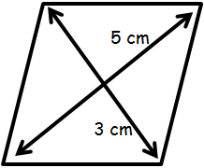

  - Trapezoid (USA) Trapezium (UK)
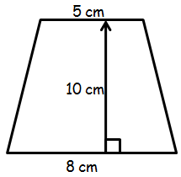
  - Kite
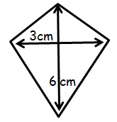
  - Parallelogram
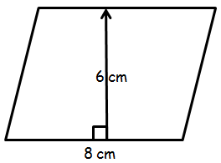
  - Arrow Head
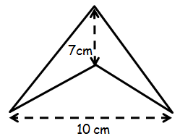
- A trapezoid paddock requires one 20kg bag of fertilizer per hectare. How many bags will the farmer need to buy? [1 ha = 10,000 m²].
